

Imaging Set Scheduler

V3.1

September 21, 2017



Table of Contents

1 Overview 3

1.1 Supported versions 3

1.2 Category 3

1.3 Special considerations 3

2 Deployment 4

2.1.1 Install Relativity application to library 4

2.1.2 Install Relativity application to workspace 4

2.1.3 Install Relativity agent 5

2.1.4 Install Relativity agent 6

3 Schedule setup 6

4 Background process 7

4.1 Manager agent process 7

4.2 Worker agent process 7

5 Releasing images 8

6 Support 9

7 Disclaimer 9

Proprietary rights 10

Overview

This solution allows you to configure an existing imaging set to run on a schedule. You can choose to run the imaging set once a day for one or many days of the week.

Supported versions

This solution is only supported for Relativity version 9.5.196.102 and above.

Category

* This custom solution consists of the following components:
* Event Handlers
* Custom Agents
* Custom Object
* Relativity Application

Special considerations

* You can only install one **KCD_1041539 - Imaging Set Scheduler Manager** agent.
* You can install multiple **KCD_1041539 - Imaging Set Scheduler Worker** agents.
* The agents can only be created on a Web server. They cannot be created on an Agent server.
* The agents use Web processing manager service to execute.
* If the web server is SSL enabled, the currently running Imaging set can only be stopped by logging into the SSL version of Relativity.
* If an Imaging Set associated with the Imaging Set Scheduler does not finish imaging before the next execution time, the application skips this next execution.
* The user who created the Imaging Set Scheduler record needs to have the following permissions to schedule an Imaging set.
* Object Security:
* Document
* Add Image
* Imaging Sets
* View/Edit/Add
* Imaging Profiles
* View
* Imaging Set Scheduler
* View/Edit/Add
* Password Bank
* View/Edit
* Tab Visibility:
* Imaging Set Scheduler
* Browsers:
* Advanced and Saved Searches
* Imaging Sets with the following statuses will skip the current execution. To get past this, a system administrator has to manually image the documents associated with the job or create a new Imaging Set Scheduler job with a new saved search.
* Stopped by User
* Error-Job Failed
* Custom components may not exhibit the same performance and behavior as native Relativity features.
* While each solution is carefully built and thoroughly tested to work on your version of Relativity, they are not considered core features and are not eligible for the same level of support as the Relativity platform.

Deployment

### Install Relativity application to library

1. Log in to Relativity.
2. **Uninstall any previous version of Imaging Set Scheduler application from all Workspaces.**
3. Navigate to the **Admin** section.
4. Click on the **Application Library** tab.
5. Click on the **Upload Application** button.
6. Click on the **Browse…** button next to **Application File**.
7. Select the file **RA_Imaging_Set_Scheduler.rap** and click **Open**.
8. Click **Save**.

### Install Relativity application to workspace

1. Log in to Relativity.
2. Navigate to the **Admin** section.
3. Click on the **Application Library** tab.
4. Click on the application **Imaging Set Scheduler.**
5. Under **Workspaces Installed**, click on the **Install** button.
6. Next to **Workspaces**, click on the **ellipsis […]** button.
7. Select one or many workspaces to install the application to.
8. Click **OK**.
9. Click **Save**.
10. You may receive the following error when installing to a workspace:

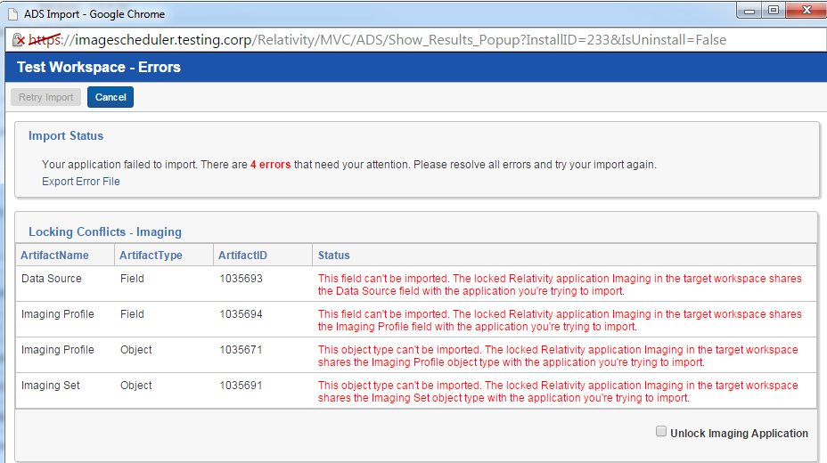

1. Check the box **Unlock Imaging Application**.
2. Click **Retry Import**.

### Install Relativity agent

*Note: You can only add one KCD_1041539 - Imaging Set Scheduler Manager agent per Relativity instance.*

1. Log in to Relativity.
2. Navigate to the **Admin** section.
3. Click on the **Agents** tab.
4. Click on the **New Agent** button.
5. Click the ellipsis next to **Agent Type**.
   1. Locate the Agent Type with the name **KCD_1041539 - Imaging Set Scheduler Manager** and select the radio button next to it.
   2. Click **OK**.
6. Click the ellipsis next to **Agent Server**.
   1. Select the Agent Server you want the agent to run on.
   2. Click **OK**.
7. Set the **Run Interval** to **60**.
8. Set the **Logging level** to the desired logging level.
9. Set **Enabled** to **Yes**.
10. Click **Save**.
11. You should see an agent in the **Agents** tab called **KCD_1041539 - Imaging Set Scheduler Manager (1).**

### Install Relativity agent

*Note: You can add multiple KCD_1041539 - Imaging Set Scheduler Worker agents per Relativity instance.*

1. Log in to Relativity.
2. Navigate to the **Admin** section.
3. Click on the **Agents** tab.
4. Click on the **New Agent** button.
5. Click the ellipsis next to **Agent Type**.
   1. Locate the Agent Type with the name **KCD_1041539 - Imaging Set Scheduler Worker** and select the radio button next to it.
   2. Click **OK**.
6. Click the ellipsis next to **Agent Server**.
   1. Select the Agent Server you want the agent to run on.
   2. Click **OK**.
7. Set the **Run Interval** to **5**.
8. Set the **Logging level** to the desired logging level.
9. Set **Enabled** to **Yes**.
10. Click **Save**.
11. You should see an agent in the **Agents** tab called **KCD_1041539 - Imaging Set Scheduler Worker (1).**

Schedule setup

1. In a workspace, click on the **Imaging Set Scheduler** tab.
2. Click on the **New Imaging Set Scheduler** button.
3. Enter the following:
   1. **Name**: Enter a descriptive name
   2. **Imaging Set**: Select the imaging set you would like to run on a schedule
   3. **Frequency**: Select the days you want the imaging set to run
   4. **Time**: Enter the time you want the imaging set to run. The time needs to be in military (24 hour time) format with both hours and minutes padded to 2 digits.
      1. For example, 5:00 PM should to be entered as 17:00
      2. For example, 7:00 AM should be entered as 07:00
   5. **Lock Images for QC**: Check the box to hide images for QC review. Uncheck the box to leave the images unlocked.
4. Click **Save**.
5. The **Next Run date** will be populated based on the selected schedule.

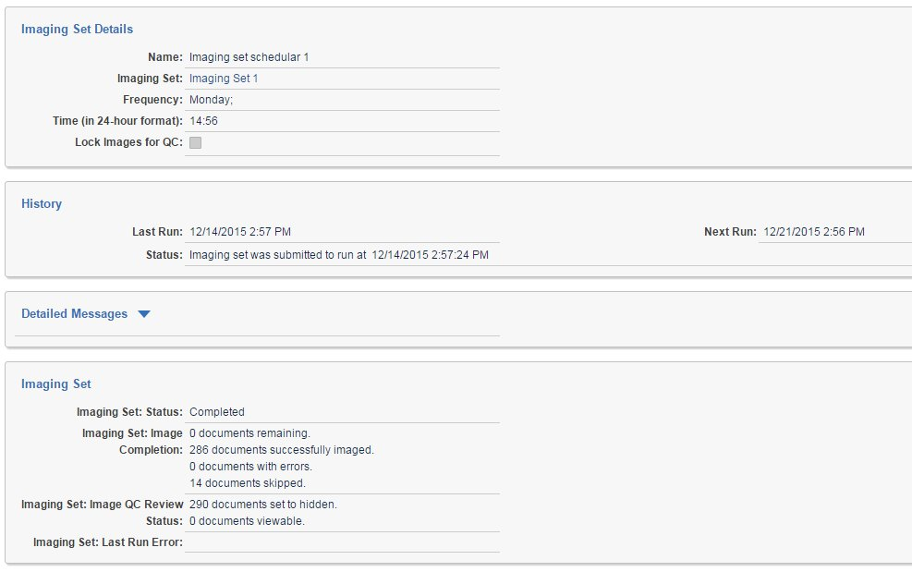

Background process

Manager agent process

* The manager agent named KCD_1041539 - Imaging Set Scheduler Manager will retrieve all imaging set schedules not currently in waiting status in all workspaces where the Imaging Set Scheduler application is installed.
* The manager agent will then check to see if the current time is past the Next Run date for each imaging set schedule. If it is, the imaging set schedule status will be set to waiting and will be queued up to be picked up by the next available worker agent.

Worker agent process

* The worker agent named KCD_1041539 - Imaging Set Scheduler Worker will retrieve the next imaging set schedule which is in waiting status.
* The associated imaging set will be submitted to the Conversion API to run.
* The conversion API then will image the documents and report progress.
* The imaging set schedule’s status, last run date and next run dates will be updated to show that the imaging set was submitted to the Conversion API.



Releasing images

* If you chose to hide images for QC, you can release those images by clicking on the Imaging Set link and then clicking **Release Images** console button on the Imaging Set record.

Imaging Set Scheduler record

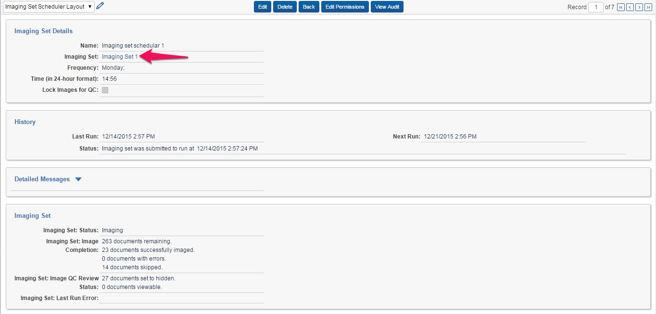

Imaging Set record

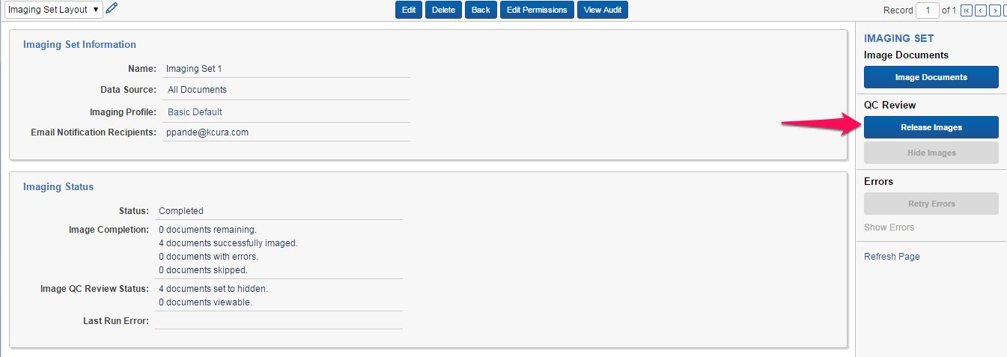

Support

For additional assistance, contact Relativity Client Services at [support@relativity.com](mailto:support@relativity.com).

Disclaimer

This script is intended for use only in the Relativity versions specified in this document and run under the guidelines presented. While each solution is carefully built and thoroughly tested to work on the versions of Relativity specified in this document, this script is not a core feature of Relativity and is not eligible for the same level of support as the Relativity platform.

In addition, custom components may not exhibit the same performance and behavior as native Relativity features. Custom solutions do not specify permission settings unless explicitly requested by the client.

Proprietary rights

This documentation (“**Documentation**”) and the software to which it relates (“**Software**”) belongs to kCura LLC and/or kCura’s third party software vendors. kCura grants written license agreements which contain restrictions. All parties accessing the Documentation or Software must: respect proprietary rights of kCura and third parties; comply with your organization’s license agreement, including but not limited to license restrictions on use, copying, modifications, reverse engineering, and derivative products; and refrain from any misuse or misappropriation of this Documentation or Software in whole or in part. The Software and Documentation is protected by the **Copyright Act of 1976**, as amended, and the Software code is protected by the **Illinois Trade Secrets Act**. Violations can involve substantial civil liabilities, exemplary damages, and criminal penalties, including fines and possible imprisonment.

**©2017. kCura LLC. All rights reserved. Relativity® and kCura® are registered trademarks of kCura LLC.**